**Exp.4 Bluetooth interface- smart phone controlled light system**

CIRCUIT DIAGRAM:

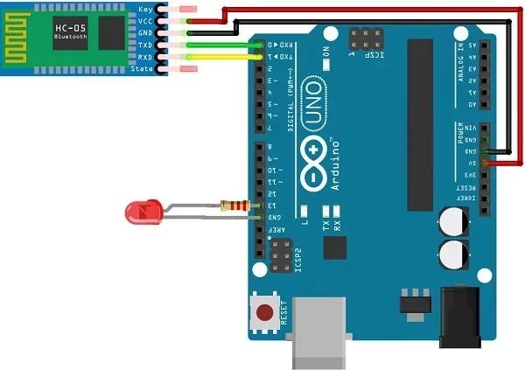

CONCEPT USED:

Bluetooth is the most popular way of connecting an Arduino to a smartphone wirelessly. In this tutorial, we will create an arduino-bluetooth interface and send messages from an arduino to smartphone and arduino to a personal computer.

CODE:

#include <SoftwareSerial.h>

SoftwareSerial Bluetooth(10, 9);

int LED = 13;

int Data;

void setup() {

  Bluetooth.begin(9600);

  Serial.begin(9600);

  Serial.println("Waiting for command...");

  Bluetooth.println("Send 1 to turn on the LED. Send 0 to turn Off");

  pinMode(LED,OUTPUT);

}

void loop() {

  if (Bluetooth.available()){

    Data=Bluetooth.read();

    if(Data=='1'){

      digitalWrite(LED,1);

      Serial.println("LED On!");

      Bluetooth.println("LED On!");

    }

    else if(Data=='0'){

       digitalWrite(LED,0);

       Serial.println("LED Off!");

       Bluetooth.println("LED  On D13 Off ! ");

    }

    else{;}

  }

delay(100);

}

Learning and Observations:

In this experiment we learnt the following:

1. Basic circuit building with Arduino uno.

2. Interfacing a bluetooth with Arduino uno.

Precaution:

1. The LED should not be connected in reversed direction because it doesn’t allow passing the current and circuit does not completed and LED will not glow.

2. The connections should be tight.

Learning Outcomes:

Via this activity we learn and acquire the skills about the following:

1. The application and usage of digital input/output pins of Arduino uno.

2. How bluetooth work and their interfacing with Arduino Uno.

3. Understood the syntax to write the basic code in Arduino IDE.

4. How to Identify the P-N Junction of LED.